Jmeter API Load Test Plan
Product ID / Name: | JSON Place holder
Product Version or Build: | V1
Present Owner : | Uttam Kumar
Created On: | 07/12/2018
Review On: | -
Review By: | -
Review Comments:
Current Version: | Placeholder_V1
Change Details:
Current Status: | Draft

Objective:

The objective of the load test is to test json placeholder site API and to benchmark how many user load, it can withstand with the current configuration.

Scope:

To test API present in JSONplace holder site and to certify the User load.

Approach:

To test the REST API of JSONplace holder site and to check anticipated user load using load user and Stress test.

Type of Testing:

1. Load testing
2. Stress tesing

Load test Process and User Distribution

Load Testing
a) Generate 2 HTTP request, one for GET and POST.
b) Set Thread limit as 100 and ramp up as 25, i.e. for 1 sec 4 threads will be triggered.
c) Add a constant timer to create a thread delay between the request
d) Execute the test for run until completion
e) Capture the Response time and Summary report for the load test.

Stress Testing
a) Generate 2 HTTP request, one for GET and POST
b) Set Thread limit as 100 and ramp up as 10, i.e. for 1 sec 10 threads will be triggered.
c) Execute the test for run until completion.
d) Capture the response time and Summary report for the load test.

Testing Tool Used:
Apache Jmeter 3.3

System / Test Environment:
a) JSON place holder website
b) Laptop configuration – Quad core processor with 8 GB RAM

Execution Results (Aggregate Results)

Load Testing Results:
Label | # Samples | Average | Median | 90% Line | Min | Max | Throughput | Received KB/sec | Sent KB/sec
GET Request | 100 | 10602 | 9963 | 17070 | 1948 | 19859 | 2.42866 | 66.48 | 0.39
POST Request | 100 | 13789 | 15800 | 20715 | 1715 | 29999 | 1.77686 | 42.05 | 42.14
TOTAL | 200 | 12196 | 12271 | 19344 | 1715 | 29999 | 3.43365 | 87.62 | 41

Response Time Graph

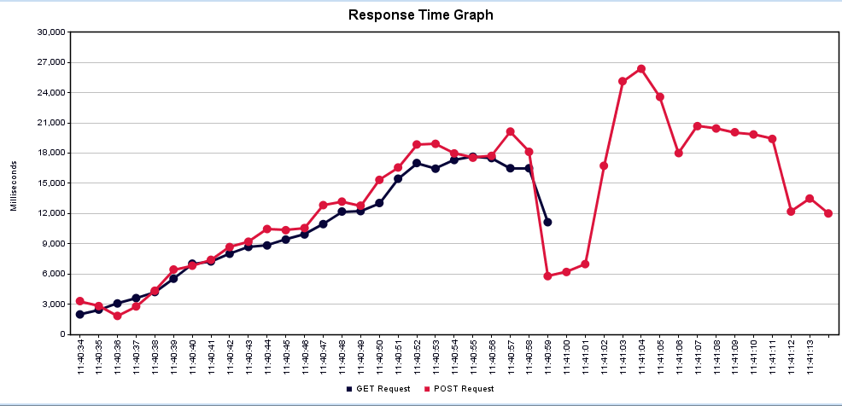

Stress Testing Results:

Label | # Samples | Average | Median | 90% Line | Min | Max | Error % | Throughput | Received KB/sec | Sent KB/sec
GET Request | 100 | 11153 | 11584 | 18487 | 1924 | 24046 | 3.00% | 3.03435 | 81.5 | 0.48
POST Request | 100 | 19060 | 20054 | 33962 | 2737 | 40928 | 29.00% | 2.0113 | 41.04 | 40.32
TOTAL | 200 | 15106 | 12202 | 31783 | 1924 | 40928 | 16.00% | 3.86496 | 91.33 | 39.05

Response Time Graph

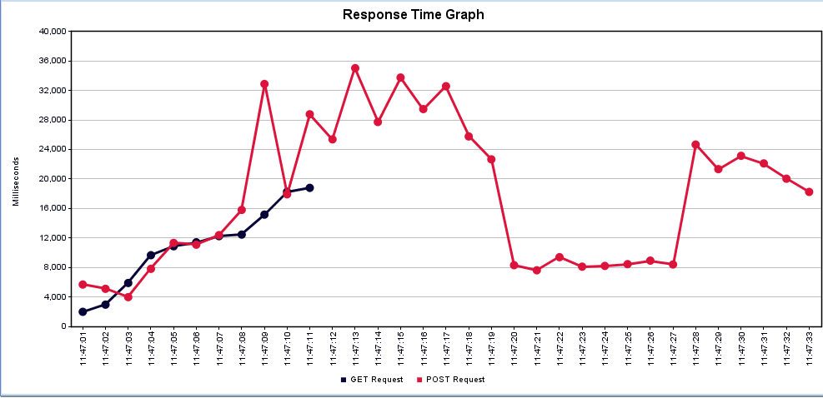

Java socket exception is thrown

